Ongoing design/UX issues for B2B Company Analyst tool
Date: 12 Jan 2026
Link to app: https://somar-company-analyst.streamlit.app/

Desktop/laptop version:
With the ‘Target Account Research’ mode selected:
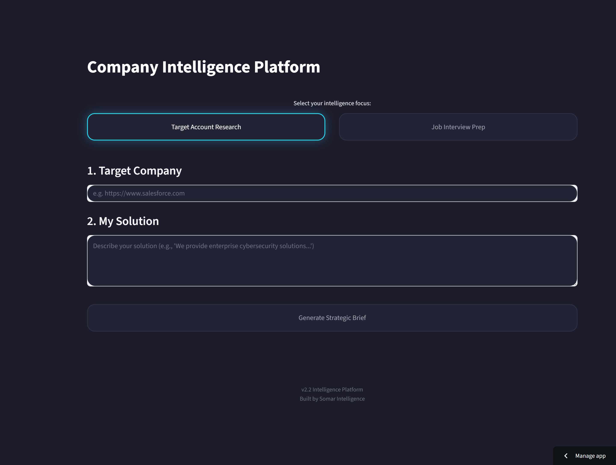
Issues:
- “Select your intelligence focus” is quite small, and perhaps needs more prominence?
- The design of the existing intelligence focus “toggle” – the two tiles next to each other (‘Target Account Research’ and ‘Job Interview Prep’) – has been updated based on changes that we were trying to make to the mobile version only. Does this new layout pass QA? Would a UX/design expert sign this off?
- When Antigravity updated the mode toggle layout on the mobile version, it appears to have then changed the colour of the ‘Generate Strategic Brief’ CTA button. It now has a dark background where we previously applied the accent/CTA colours (#22D3EE, #06B6D4) enclosed below in the “Brand colour & style system” notes. This needs fixing
- The same issue applies when you select the Job Interview Prep mode:
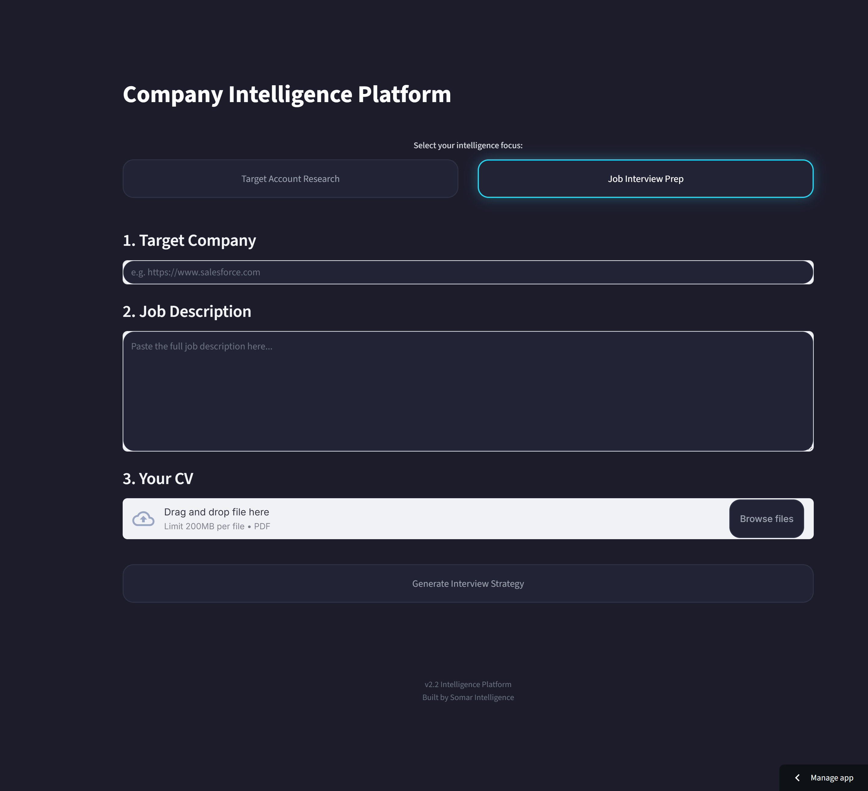
- Approaching the app UI with fresh eyes, is it clear enough what this tool does/offers? Does it need an explanatory sub-title or single explanatory sentence at the top? Ideally a subtitle I think, to save on space. If so, I want Claude to suggest some options based on what my tool does
- Also, further to the previous point, is ‘Company Intelligence Platform’ the perfect title for my app? Does it accurately cover what both modes offer? Is it instantly clear enough to a new user? Can we leave it as is, if we add a qualifying subtitle?

Mobile version:
This is taken from my Android smartphone Google Pixel 7:
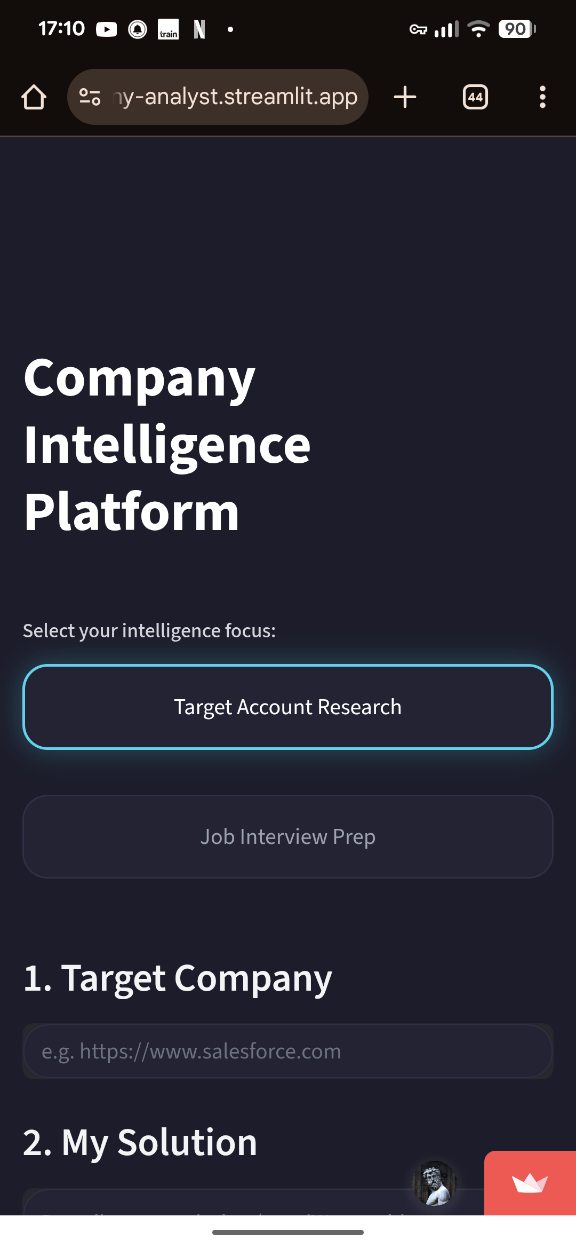
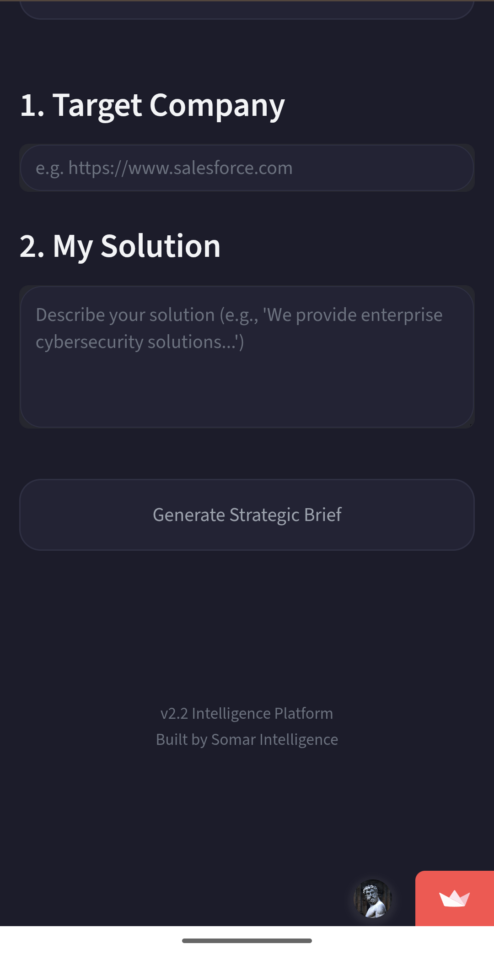
Issues:
- I’m not 100% certain about the mode selection toggle. It seems a little bit floaty, also there is perhaps a bit too much vertical space in-between the two buttons (‘Target Account Research’ and ‘Job Interview Prep’)? I would like a UX critique here – is the best way that we can offer the mode selection option on mobile?
- The last round of changes that I submitted to Antigravity was supposed to fix issues with the mobile UI/UX only, but it seems that the changes were applied to the desktop/laptop too. Do we need to have a single mode toggle format that must work across all devices, or can we have two design versions: one optimised for desktop and one for laptop? What would a design/UX expert do? I need my app UI to be device-responsive/optimised but also stable.
- As you can see, same issue with the CTA buttons.

# Critical UX Fixes Required - Multi-Device Responsive Issues

## Context
Recent mobile-specific changes have inadvertently affected desktop layout and broken brand compliance. This prompt addresses ALL outstanding issues across devices.

---

## 🔴 CRITICAL: Fix #1 - Restore Cyan CTA Buttons

### Problem
"Generate Strategic Brief" and "Generate Interview Strategy" buttons have lost their cyan color - they now appear dark (`#232335`-ish) instead of brand accent cyan.

### Required Fix
Restore CTA buttons to brand standards per `somar_brand_colour_style_system.md`:
```css
.stButton button {
background: #22D3EE !important; /* Primary accent cyan */
color: #1C1C2B !important; /* Dark text for contrast */
border: none !important;
font-weight: 600 !important;
transition: background 0.3s ease !important;
}

.stButton button:hover {
background: #06B6D4 !important; /* Accent hover state */
}
```

**This must work on BOTH desktop and mobile.**

---

## 🔴 CRITICAL: Fix #2 - Separate Desktop vs Mobile Mode Toggle CSS

### Problem
Mobile-specific CSS changes have broken desktop layout:
- Cards have unequal widths on desktop
- Desktop should show side-by-side, mobile should stack vertically
- Current CSS is applying mobile rules to all breakpoints

### Required Solution: Responsive Breakpoints

**Desktop (≥769px): Side-by-Side Horizontal Cards**
```css
/* Desktop: Side-by-side layout */
@media (min-width: 769px) {
div[data-testid="stRadio"] > div[role="radiogroup"] {
flex-direction: row !important;
justify-content: center !important;
gap: 1rem !important;
align-items: stretch !important;
}

div[data-testid="stRadio"] > div[role="radiogroup"] > label {
flex: 0 1 240px !important; /* Fixed width cards, equal size */
min-height: 5rem !important;
text-align: center !important;
justify-content: center !important;
}
}
```

**Mobile (≤768px): Stacked Vertical Cards**
```css
/* Mobile: Stacked full-width cards */
@media (max-width: 768px) {
div[data-testid="stRadio"] {
width: 100% !important;
padding: 0 1rem !important;
}

div[data-testid="stRadio"] > div[role="radiogroup"] {
flex-direction: column !important;
align-items: stretch !important;
gap: 0.75rem !important; /* Reduced from ~1.5rem */
}

div[data-testid="stRadio"] > div[role="radiogroup"] > label {
width: 100% !important;
min-height: 3.5rem !important;
text-align: left !important;
justify-content: flex-start !important;
padding: 1rem 1.25rem !important;
}
}
```

**Key differences:**
- Desktop: Fixed-width cards (240px), centered horizontally, side-by-side
- Mobile: Full-width cards, left-aligned, stacked vertically, tighter spacing

---

## ⚠️ HIGH PRIORITY: Fix #3 - Increase Label Prominence

### Problem
"Select your intelligence focus:" label is too small and lacks visual hierarchy.

### Required Fix
```css
/* Increase label size and weight */
.stRadio > label:first-of-type,
div[data-testid="stRadio"] + div > p {
font-size: 1rem !important; /* Up from ~0.9rem */
font-weight: 500 !important;
color: #FFFFFF !important; /* Primary text color, not muted */
margin-bottom: 1rem !important;
}
```

**Alternative:** If above selector doesn't work, add this to the inline style in Python:
```python
st.markdown(
'<p style="text-align: center; color: #FFFFFF; font-size: 1rem; '
'font-weight: 500; margin-bottom: 1rem;">Select your intelligence focus:</p>',
unsafe_allow_html=True
)
```

---

## 📱 MEDIUM PRIORITY: Fix #4 - Add Explanatory Subtitle

### Problem
"Company Intelligence Platform" alone doesn't explain what the tool does.

### Proposed Solution
Add a subtitle immediately below the main title:
```python
# Main title
st.markdown('<h1 style="text-align: center; color: #FFFFFF; font-size: 2.5rem; '
'margin-bottom: 0.5rem;">Company Intelligence Platform</h1>',
unsafe_allow_html=True)

# NEW: Subtitle
st.markdown('<p style="text-align: center; color: #C7C9D3; font-size: 1.1rem; '
'font-weight: 400; margin-bottom: 2.5rem;">AI-powered research for '
'sales outreach and interview preparation</p>',
unsafe_allow_html=True)
```

**Subtitle options** (choose one):

**Option A (Functional):**
"AI-powered research for sales outreach and interview preparation"

**Option B (Benefit-focused):**
"Generate strategic briefs in seconds with AI-powered company intelligence"

**Option C (Concise):**
"Smart company research for sales teams and job seekers"

**Option D (Professional):**
"Instant strategic intelligence for B2B professionals"

**My recommendation:** Option A - most accurate, clear value prop for both modes.

---

## Testing Requirements

After implementing all fixes, verify:

### Desktop (≥769px)
- [ ] Mode cards are equal width (~240px each)
- [ ] Cards display side-by-side horizontally
- [ ] CTA button is cyan (`#22D3EE`)
- [ ] Label "Select your intelligence focus" is 16px+, white color
- [ ] Subtitle appears below main title

### Mobile (≤768px)
- [ ] Mode cards are full-width (minus 1rem padding each side)
- [ ] Cards stack vertically with 0.75rem gap
- [ ] CTA button is cyan (`#22D3EE`)
- [ ] Touch targets are comfortable (≥44px height)
- [ ] Label is left-aligned on mobile
- [ ] Subtitle is readable and doesn't cause overflow

### Both Devices
- [ ] Mode switching works correctly
- [ ] Session state persists
- [ ] All brand colors match `somar_brand_colour_style_system.md`

---

## Root Cause Analysis

The current issues stem from:
1. **Missing `@media` query separation** - Mobile CSS is affecting desktop
2. **CTA button regression** - Something overrode the cyan background
3. **Fixed widths without breakpoint context** - Cards stretching incorrectly

**Solution:** Properly scoped responsive CSS with explicit breakpoint rules.

---

## Priority Order

1. 🔴 **Fix cyan buttons** (brand violation + affects conversions)
2. 🔴 **Separate desktop/mobile CSS** (layout is broken)
3. ⚠️ **Increase label prominence** (usability)
4. 📱 **Add subtitle** (clarity for new users)

Please implement in this order and test after each fix.

Brand colour & style system
This document defines the Somar Consulting visual system. It is designed to be shared with designers, developers, and AI tools so that all outputs are visually consistent, restrained, and on-brand.
The goal is clarity, consistency, and calm authority. This is not a moodboard. It is a working system.

1. Colour system
Colours are defined by role, not decoration. No additional colours should be introduced unless they serve a clear functional purpose.
1.1 Foundational neutrals
These form the backbone of all layouts.
- Primary background
#1C1C2B
Use for main page backgrounds and full-screen sections.
- Panel / surface
#232335
Use for cards, containers, elevated sections.
- Border / divider
#2F3045
Use for outlines, separators, tables, and subtle structure.

1.2 Typography colours
Text colour is intentionally limited to preserve hierarchy and readability.
- Primary text
#FFFFFF
Headlines, body copy, primary labels.
- Secondary / muted text
#C7C9D3
Supporting copy, captions, helper text, metadata.

1.3 Accent colours (action only)
Accent colours indicate interaction and intent. They are not decorative.
- Primary accent / CTA
#22D3EE
Buttons, links, active states.
- Accent hover / active
#06B6D4
Hover, focus, and pressed states.
Rule: Accent colours should appear only where user action is expected.

1.4 System tokens (non-brand)
These support the UI but are not part of the brand palette.
- Shadow
rgba(0, 0, 0, 0.35)
- Corner radius
18px

2. Typography system
2.1 Font family
- Primary font: Inter
Inter is used across all touchpoints:
- Website
- Tools and apps
- Presentations
- Documentation
Guidelines:
- Use Inter Regular, Medium, and SemiBold only
- Avoid excessive weight variation
- Prioritise readability over visual flourish

3. Visual style principles
These principles guide decisions when the rules do not explicitly specify an answer.
3.1 Core style
- Clean
- Minimalist
- Calm
- Precise
- Confident
3.2 What Somar avoids
- Decorative colour usage
- Gradients unless functionally justified
- Overuse of icons
- Busy backgrounds
- Stock photography or clichéd AI imagery
3.3 Layout & composition
- Generous whitespace
- Clear visual hierarchy
- Grid-based layouts
- Few elements per screen
- Emphasis on structure over ornamentation

4. Usage guidance for humans and AI
When creating assets for Somar Consulting:
- Do not invent new colours
- Do not introduce additional fonts
- Use accent colour only for actions
- Prefer subtraction over addition
- When unsure, choose the simpler option
This system is intentionally restrained. Consistency matters more than novelty.

5. Versioning
- Version: 1.0
- Status: Approved
- Owner: Somar Consulting

